Vital Signs Vocabulary

Objective
- Vital signs are important indicators of health states of the body.
- Vital signs are defined as various determinations that provide information about the basic body conditions of the patient.
- By the end of this lesson every student will be able to define all of the words in this Vital Signs Vocabulary.
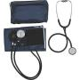
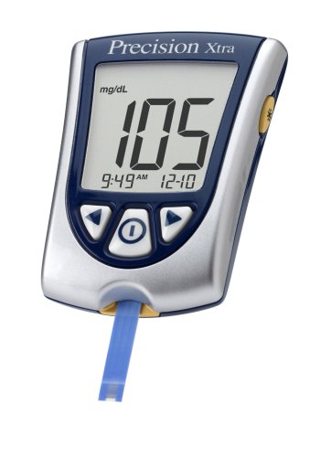
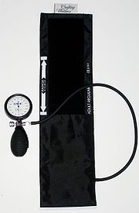
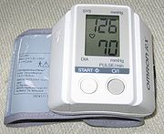
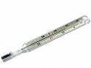
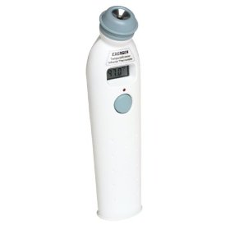
- Students will be able to identify the medical equipment normally used by Health Care professionals in assessing a patient’s vital signs.
- Students will be able to demonstrate the proper procedures to take a set of Vital Signs on a partner and accurately demonstrate that skill to the teacher in under 3 minutes.

Medical Equipment:
In order to obtain a complete set of vital signs for a patient, you will be required to know and use the following basic medical equipment:
- Stethoscope
- Thermometer
- Blood Pressure Cuff
- Glucometer
- Watch with second hand

Medical Equipment Definitions:

Stethoscope: The stethoscope is an instrument used for Auscultation, or listening to the sounds produced by the body. It is used primarily to listen to the lungs, heart and intestinal tract. It is also used to listen to blood flow in peripheral vessels and the heart sounds of developing fetuses in pregnant women.

Thermometer: Medical thermometers are used for measuring human body temperature, with the tip of the thermometer being inserted either into the mouth (oral temperature), under the armpit (axillary temperature), or into the rectum via the anus (rectal temperature).

Blood Pressure Cuff: A sphygmomanometer or blood pressure cuff is a device used to measure blood pressure, comprising an inflatable cuff to restrict blood flow, and a mercury or mechanical manometer to measure the pressure. It is always used in conjunction with a means to determine at what pressure blood flow is just starting, and at what pressure it is unimpeded. Manual sphygmomanometers are used in conjunction with a stethoscope.

Glucometer: A glucose meter (or glucometer) is a medical device for determining the approximate concentration of glucose in the blood. It is a key element of home blood glucose monitoring (HBGM) by people with diabetes mellitus or hypoglycemia. A small drop of blood, obtained by pricking the skin with a lancet, is placed on a disposable test strip that the meter reads and uses to calculate the blood glucose level. The meter then displays the level in mg/dl (milligrams per deciliter)

Watch with a sweep second hand: Traditionally, watches have displayed the time in analog form, with a numbered dial upon which are mounted at least a rotating hour hand and a longer, rotating minute hand. Many watches also incorporate a third hand that shows the current second of the current minute.

Measurable Vital Signs
- Body Temperature
- Pulse
- Blood Pressure
- Respiratory Rate

Two vital signs that may be important but are not considered “Major Vital Signs” are Body Weight and Blood Glucose Level (Blood Sugar Level).

measurable vital signs Definitions:

Vital signs are measures of various physiological statistics, often taken by health professionals, in order to assess the most basic body functions. Vital signs are an essential part of a case presentation. The act of taking vital signs normally entails recording Body temperature, Pulse rate (or heart rate), Blood pressure, and Respiratory rate, but may also include other measurements. Vital signs often vary by age.

- Body Temperature - Normal human body temperature, also known as normothermia or euthermia, is a concept that depends upon the place in the body at which the measurement is made, and the time of day and level of activity of the body. There is no single number that represents a normal or healthy temperature for all people under all circumstances using any place of measurement.

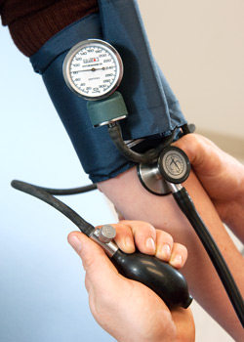
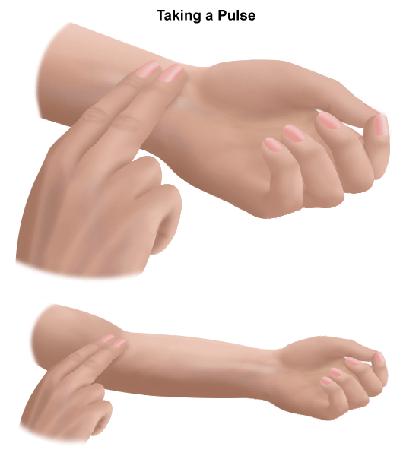
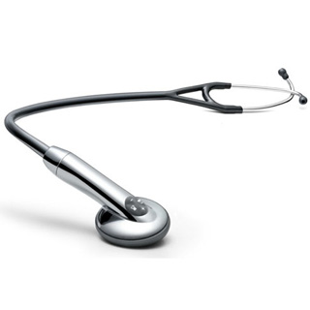
- Pulse - In medicine, a person's pulse is the arterial palpation of a heartbeat.[1] It can be palpated in any place that allows for an artery to be compressed against a bone, such as at the neck (carotid artery), at the wrist (radial artery), behind the knee (popliteal artery), on the inside of the elbow (brachial artery), and near the ankle joint (posterior tibial artery). The pulse rate can also be measured by measuring the heart beats directly (the apical pulse).

- Blood Pressure - Blood pressure (BP) is a force exerted by circulating blood on the walls of blood vessels, and is one of the principal vital signs. During each heartbeat, BP varies between a maximum (systolic) and a minimum (diastolic) pressure. The mean BP, due to pumping by the heart and resistance in blood vessels, decreases as the circulating blood moves away from the heart through arteries. It has its greatest decrease in the small arteries and arterioles, and continues to decrease as the blood moves through the capillaries and back to the heart through veins.[1] Gravity, valves in veins, and pumping from contraction of skeletal muscles, are some other influences on BP at various places in the body. The term blood pressure usually refers to the pressure measured at a person's upper arm. It is measured on the inside of an elbow at the brachial artery, which is the upper arm's major blood vessel that carries blood away from the heart. A person's BP is usually expressed in terms of the systolic pressure and diastolic pressure, for example 115/75.

- Respiratory Rate - In physiology, respiration (or just breathing) is defined as the transport of oxygen from the outside air to the cells within tissues, and the transport of carbon dioxide in the opposite direction. This is in contrast to the biochemical definition of respiration, which refers to cellular respiration: the metabolic process by which an organism obtains energy by reacting oxygen with glucose to give water, carbon dioxide and ATP (energy). Although physiologic respiration is necessary to sustain cellular respiration and thus life in animals, the processes are distinct: cellular respiration takes place in individual cells of the animal, while physiologic respiration concerns the bulk flow and transport of metabolites between the organism and the external environment.


- Blood Glucose Level - The blood sugar concentration or blood glucose level is the amount of glucose (sugar) present in the blood of a human or animal. Normally, in mammals the body maintains the blood glucose level at a reference range between about 3.6 and 5.8 mM (mmol/L). It is tightly regulated as a part of metabolic homeostasis.

- Body Weight - Although some people prefer the less-ambiguous term body mass, the term body weight is overwhelmingly used in daily English speech as well as in the contexts of biological and medical sciences to describe the mass of an organism's body. Body weight is measured in kilograms throughout the world, although in some countries people more often measure and describe body weight in pounds (e.g. United States and Canada) or stones and pounds (e.g. among people in the Commonwealth of Nations) and thus may not be well acquainted with measurement in kilograms. Most hospitals, even in the United States, now use kilograms for calculations, but use kilograms and pounds together for other purposes. (1 kg is approximately 2.2 lb; 1 stone (14 lb) is approximately 6.4 kg.)

Vital Signs Medical Terminology:

- Apical - Pertaining to the apex or pointed end of the heart
- Apical Pulse - Pulse taken with a stethoscope and near the apex of the heart
- Apnea - Absence of respirations; temporary cessation of respirations
- Arrhythmia -Irregular or abnormal rhythm, usually referring to the heart rhythm
- Axilla - Armpit, the area of the body under the arm
- Auscultation - The act of listening for sounds within the body
- Blood Pressure -Pressure of circulating blood against the walls of the arteries
- Bradycardia - Slow heart rate, usually below 60 beats a minute
- Bradypnea - Slow respiratory rate, usually below 10 respirations a minute

- Capillary Refill - is the rate at which blood refills empty capillaries. It can be measured by holding a hand higher than heart-level (prevents venous reflux), pressing a fingernail until it turns white, and taking note of the time needed for color to return once the nail is released
- Cardiac Arrest - Sudden stopping of heart action
- Carotid Pulse - felt along the long carotid artery on either side of the neck
- Clinical Thermometers - may be used to record temperatures
- Constrict - To get smaller
- Cyanosis - A dusky, bluish discoloration of the skin, lips, and/or nail beds as a result of decreased oxygen and increased carbon dioxide in the bloodstream.
- Diastolic Blood Pressure - The pressure remaining in the arteries during ventricular relaxation
- Dilate - To get larger
- Dyspnea - Difficult or labored breathing
- Electronic Thermometers - This type of thermometer registers the temperature on a viewer in a few seconds.
- Fever - Elevated body temperature, usually above 101 degrees F, rectally
- Height - Is the measurement of the length of the human body, from the bottom of the feet to the top of the head, when standing erect.
- Homeostasis - Is the ideal health state in the human body.
- Hypertension - High blood pressure
- Hyperthermia - Occurs when the body temperature exceeds 104 degrees, measured rectally.
- Hypotension - Low blood pressure
- Hypothermia - A low body temperature, below 95 degrees measured rectally.
- Oral temperatures - Are taken in the mouth. This is usually the most common, convenient, and comfortable method of obtaining a temperature.
- Palpation - Technique used to feel the texture, size, consistency, and location of parts of the body with the hands
- Percussion - Technique of tapping with the fingertips to evaluate size, borders, and consistency of internal structures of the body
- Pulse - Pressure of the blood felt against the wall of an artery as the heart contracts or beats
- Pulse deficit - The difference between the rate of an apical pulse and the rate of a radial pulse
- Pulse pressure - The difference between systolic and diastolic blood pressure
- Pupil - The black center of the eye
- Radial Pulse - The pulse felt at the wrist
- Rate - Number per minute, as with pulse and respiration counts
- Reactivity - In the pupil of the eyes, reacting to light by changing size
- Rectal temperatures - Are taken in the rectum and is the most accurate of all methods
- Respiration - the process of taking in oxygen (02) and expelling carbon dioxide (CO2) from the lungs and respiratory tract.
- Rhythm - Referring to regularity; regular or irregular
- Sign - An indication of a patient's condition that is objective, or can be observed by another person; an indication that can be seen, heard, smelled or felt by the medical practitioner
- Sphygmomanometer - instrument calibrated for measuring blood pressure in millimeters of mercury (mm Hg)
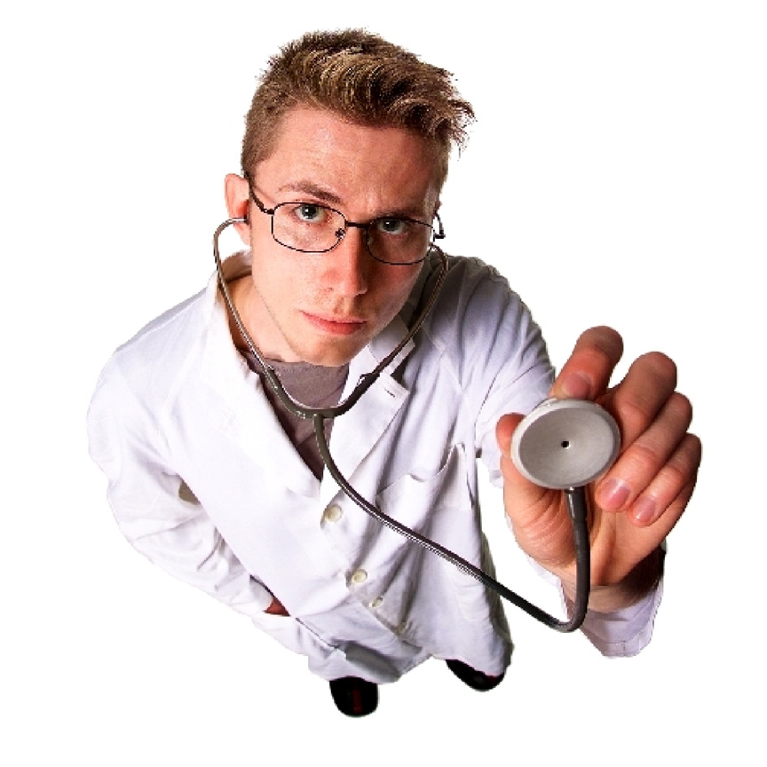
- Stethoscope - Instrument used for listening to internal body sounds
- Symptom - An indication of a patient's condition that cannot be observed by another person but rather is subjective, or felt and reported by the patient
- Systolic Blood Pressure - The pressure created in the arteries by the blood during ventricular contraction
- Tachycardia - Fast, or rapid, heartbeat (usually more than 100 beats per minute in an adult)
- Tachypnea - Respiratory rate above 25 respirations per minute.
- Temperature - The balance between heat lost an heat produced by the body
- Thermometer - Instrument used to measure temperature
- Tympanic Thermometers - are specialized electronic thermometers that record the aural temperature in the ear.
- Vital Signs - Outward signs of what is going on inside the body, including respiration; pulse; skin color, temperature, and condition (plus capillary refill in infants and children); pupils; and blood pressure

Vital Signs Vocabulary Student Worksheet #1
Student’s Name: ___________________________ Class Period:___________________

Objectives:
- Vital signs are important __________________of health states of the body.
- Vital signs are defined as various determinations that provide information about the basic body ______________ of the patient.
- By the end of this lesson every student will be able to _________ all of the words in this ________ _________ Vocabulary.
- Students will be able to identify the Medical ______________ normally used by Health Care professionals in assessing a patient’s vital signs.
- Students will be able to _______________ the proper procedures to take a set of Vital Signs on a partner and accurately demonstrate that skill to the teacher in under 3 minutes.

Medical Equipment:
In order to obtain a complete set of vital signs for a patient, you will be required to know and use the following basic medical equipment. List the 5 pieces of medical equipment you will need in order to obtain a complete set of vital signs.
- _______________________________
- _______________________________
- _______________________________
- _______________________________
- _______________________________

Define the following terms:
- Body Temperature: ____________________________________________________________________________________________________________________________________________________________________________________________________________________________________________________________________________________________________________

- Pulse: ___________________________________________________________________________________________________________________________________________________________________________________________________________________________________________________________________________________________________________
- Blood Pressure: ____________________________________________________________________________________________________________________________________________________________________________________________________________________________________________________________________________________________________________
- Respiratory Rate: ____________________________________________________________________________________________________________________________________________________________________________________________________________________________________________________________________________________________________________
- Blood Glucose Level: ____________________________________________________________________________________________________________________________________________________________________________________________________________________________________________________________________________________________________________
- Body Weight: ____________________________________________________________________________________________________________________________________________________________________________________________________________________________________________________________________________________________________________
- Vital Signs: ___________________________________________________________________________________________________________________________________________________________________________________________________________________________________________________________________________________________________________
- Stethoscope: ____________________________________________________________________________________________________________________________________________________________________________________________________________________________________________________________________________________________________________
- Medical Thermometer: ____________________________________________________________________________________________________________________________________________________________________________________________________________________________________________________________________________________________________________

- Sphygmomanometer (Blood Pressure Cuff): ____________________________________________________________________________________________________________________________________________________________________________________________________________________________________________________________________________________________________________
- Glucometer: ____________________________________________________________________________________________________________________________________________________________________________________________________________________________________________________________________________________________________________
- Watch with second hand: ____________________________________________________________________________________________________________________________________________________________________________________________________________________________________________________________________________________________________________

Place the correct Vital Sign Term in the blank space:
- _____________________ Pertaining to the apex or pointed end of the heart
- _____________________ The pressure remaining in the arteries during ventricular relaxation
- _____________________ An indication of a patient's condition that cannot be observed by another person but rather is subjective, or felt and reported by the patient
- _____________________ instrument calibrated for measuring blood pressure in millimeters of mercury (mm Hg)
- _____________________ Outward signs of what is going on inside the body, including respiration; pulse; skin color, temperature, and condition (plus capillary refill in infants and children); pupils; and blood pressure
- _____________________ The act of listening for sounds within the body
- _____________________ An indication of a patient's condition that cannot be observed by another person but rather is subjective, or felt and reported by the patient
- _____________________ Occurs when the body temperature exceeds 104 degrees, measured rectally.
- _____________________ A dusky, bluish discoloration of the skin, lips, and/or nail beds as a result of decreased oxygen and increased carbon dioxide in the bloodstream.
- _____________________ Technique used to feel the texture, size, consistency, and location of parts of the body with the hands

Vital Signs Vocabulary Student Worksheet #2
Student’s Name: ___________________________ Class Period:___________________

Vital Signs Medical Terminology:

- Apical: ______________________________________________________________________________________________________________________________________________________________________________________________________________________________
- Apical Pulse: ______________________________________________________________________________________________________________________________________________________________________________________________________________________________
- Apnea: ______________________________________________________________________________________________________________________________________________________________________________________________________________________________
- Arrhythmia: ______________________________________________________________________________________________________________________________________________________________________________________________________________________________
- Axilla: ______________________________________________________________________________________________________________________________________________________________________________________________________________________________
- Auscultation: ______________________________________________________________________________________________________________________________________________________________________________________________________________________________
- Blood Pressure: ______________________________________________________________________________________________________________________________________________________________________________________________________________________________
- Bradycardia: ______________________________________________________________________________________________________________________________________________________________________________________________________________________________
- Bradypnea: ______________________________________________________________________________________________________________________________________________________________________________________________________________________________
- Capillary Refill: ______________________________________________________________________________________________________________________________________________________________________________________________________________________________
- Cardiac Arrest: ______________________________________________________________________________________________________________________________________________________________________________________________________________________________
- Carotid Pulse: ______________________________________________________________________________________________________________________________________________________________________________________________________________________________
- Clinical Thermometers: ______________________________________________________________________________________________________________________________________________________________________________________________________________________________
- Constrict: ______________________________________________________________________________________________________________________________________________________________________________________________________________________________
- Cyanosis: ______________________________________________________________________________________________________________________________________________________________________________________________________________________________
- Diastolic Blood Pressure: ______________________________________________________________________________________________________________________________________________________________________________________________________________________________
- Dilate: ______________________________________________________________________________________________________________________________________________________________________________________________________________________________
- Dyspnea: ______________________________________________________________________________________________________________________________________________________________________________________________________________________________
- Electronic Thermometers: ______________________________________________________________________________________________________________________________________________________________________________________________________________________________
- Fever: ______________________________________________________________________________________________________________________________________________________________________________________________________________________________
- Height: ______________________________________________________________________________________________________________________________________________________________________________________________________________________________

- Homeostasis: ______________________________________________________________________________________________________________________________________________________________________________________________________________________________
- Hypertension: ______________________________________________________________________________________________________________________________________________________________________________________________________________________________
- Hyperthermia: ______________________________________________________________________________________________________________________________________________________________________________________________________________________________
- Hypotension: ______________________________________________________________________________________________________________________________________________________________________________________________________________________________
- Hypothermia: ______________________________________________________________________________________________________________________________________________________________________________________________________________________________
- Oral temperatures: ______________________________________________________________________________________________________________________________________________________________________________________________________________________________
- Palpation: ______________________________________________________________________________________________________________________________________________________________________________________________________________________________
- Percussion: ______________________________________________________________________________________________________________________________________________________________________________________________________________________________
- Pulse: ______________________________________________________________________________________________________________________________________________________________________________________________________________________________
- Pulse deficit: ______________________________________________________________________________________________________________________________________________________________________________________________________________________________
- Pulse pressure: ______________________________________________________________________________________________________________________________________________________________________________________________________________________________

- Pupil: ______________________________________________________________________________________________________________________________________________________________________________________________________________________________
- Radial Pulse: ______________________________________________________________________________________________________________________________________________________________________________________________________________________________
- Rate: ______________________________________________________________________________________________________________________________________________________________________________________________________________________________
- Reactivity: ______________________________________________________________________________________________________________________________________________________________________________________________________________________________
- Rectal temperatures: ______________________________________________________________________________________________________________________________________________________________________________________________________________________________
- Respiration: ______________________________________________________________________________________________________________________________________________________________________________________________________________________________
- Rhythm: ______________________________________________________________________________________________________________________________________________________________________________________________________________________________
- Sign: ________________________________________________________________________________________________________________________________________________________________________________________________________________________________________________________________________________________________________
- Sphygmomanometer: ______________________________________________________________________________________________________________________________________________________________________________________________________________________________
- Stethoscope: ______________________________________________________________________________________________________________________________________________________________________________________________________________________________
- Symptom: ______________________________________________________________________________________________________________________________________________________________________________________________________________________________

- Systolic Blood Pressure: ______________________________________________________________________________________________________________________________________________________________________________________________________________________________
- Tachycardia: ______________________________________________________________________________________________________________________________________________________________________________________________________________________________
- Tachypnea: ______________________________________________________________________________________________________________________________________________________________________________________________________________________________
- Temperature: ______________________________________________________________________________________________________________________________________________________________________________________________________________________________
- Thermometer: ______________________________________________________________________________________________________________________________________________________________________________________________________________________________
- Tympanic Thermometers: ______________________________________________________________________________________________________________________________________________________________________________________________________________________________
- Vital Signs: ______________________________________________________________________________________________________________________________________________________________________________________________________________________________

