Temperature Conversion

Write the temperature shown on each thermometer

1)

10 ºC = ºF
2) 3) 4)

77 ºF = ºC —30 ºC = ºF 23 ºF = ºC

Formula to convert ºC to ºF
Formula to convert ºF to ºC

F = 1.8
C + 32

C = 5 (F 9

− 32)

Convert Celsius into Fahrenheit Convert Fahrenheit into Celsius

- 50 ºC = ºF

- 75 ºC = ºF

- 80 ºC = ºF
- 203 ºF = ºC

- 86 ºF = ºC

- 149 ºF = ºC

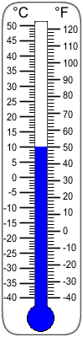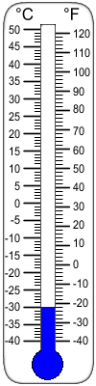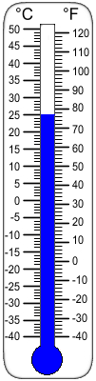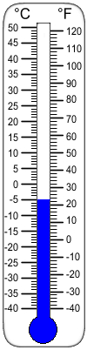

8) 45 oC = oF 12) 158 ºF = ºC

Answer Key

Write the temperature shown on each thermometer

1)

10 ºC = 50 ºF
2) 3) 4)

77 ºF = 25 ºC —30 ºC = —22 ºF 23 ºF = —5 ºC

Formula to convert ºC to ºF
Formula to convert ºF to ºC

F = 1.8
C + 32

C = 5 (F 9

− 32)

Convert Celsius into Fahrenheit Convert Fahrenheit into Celsius

5) 50 ºC = 122 ºF

oF oF oF
6) 75 ºC | = | 167
7) 80 ºC | = | 176
8) 45 ºC | = | 113

9) 203 ºF = 95 ºC

10) 86 ºF = 30 ºC 11) 149 ºF = 65 ºC 12) 158 ºF = 70 ºC

