Student’s Name
Herman Minor
ENGL111-7BC
November 4, 2016
Arguing Essay
The Essential Oils Pocket Reference tells us that essential oils have been around since ancient times. However, their recent rediscovery in modern times has brought about scientific study of their uses as a means to ward off infectious diseases, aid in faster recovery from infectious illness, and treatment of certain disorders. These studies can now be conducted using high technology and equipment, and state of the art laboratories and manufacturing facilities, unlike their crude beginnings of the past (p.11). Thesis: Essential oils are a reliable source of alternative and complimentary treatments, versus modern medicine alone, as means of maintaining health and well-being.
In disclosing the reasoning behind why she began seeking alternatives to modern medicine and using essential oils, Dr. LeAnne Deardeuff, DC, says, “I became interested in natural healing in 1988 after years of migraine headaches, chronic fatigue and allergies. I was strictly a Western allopathic medicine person until then. After I had lain in bed for most of the time during a three-year stretch, the medical profession finally told me that my problem was psychological; that I didn’t like to do housework so I was bringing this problem on myself. They recommended to my husband that he divorce me because I was ‘lazy’” (p. x of Introduction of Inner Transformations Using Essential Oils). Clearly she had been let down by modern medicine, so she began to examine her alternatives.
Dr. Deardueff’s first experience with essential oils did not win her over. She later learned that the tea tree oil she initially tried was not of high quality or purity, therefore was not effective in clearing up her fungal infection as she had been led to believe it would. Dr. Deardueff goes on to explain in the introduction of her book (pp. ix-xi), that once she discovered the difference in quality and purity from brand to brand of essential oils, she did lots of research on the brands/companies she felt were the best. She read everything about them that she could find, she listened to informational tapes on them, and attended seminars and training sessions. But in the end she felt the best education she could receive was from trying the oils on herself, friends, family and patients. She tried them all to experience what they did firsthand. In doing so she was able to determine what worked for her so that she could in turn recommend them to her patients for their ailments as well.
Her book, Inner Transformations Using Essential Oils, chronicles Dr. Deardueff’s findings and suggested protocols, as a doctor of chiropractic medicine, for such things as colon cleanse, kidney cleanse, liver cleanse and finally a master cleanse. Her belief is that may chronic illnesses are simply due to a buildup of toxins in the body and that by eliminating the toxins your overall health improves. She lists a remedy for kidney stones which uses Rosemary, Geranium, and Juniper essential oils in a drink along with other natural ingredients. She recommends a compress of a hot wet towel with drops of Rosemary, Sage, Juniper and Idaho Balsam Fir added and placed over the back covering the kidney area for kidney stone pain. She adds that properties in the Idaho Balsam Fir oil help to dilate the ureter to help the stone pass (51-52).
As mentioned earlier, one of Dr. Deardueff’s first experiences with essential oils was with tea tree oil. While she didn’t initially have success treating her fungal infection due to the poor quality of the oil she used, there are studies that show tea tree oil IS an effective treatment against Candida albicans – a fungal infection caused by yeast. One such study, conducted in Poland by Anna Mertas and her colleagues from the Department of Microbiology and Immunology of the Medical University of Silesia in Katowice, showed that tea tree oil is even effective on fungal infections that are resistant to the common prescription anti-fungal medication Fluconazale (Mertas, et al, p. 8).
In Appendix B of her book, Dr. Deardueff notes the use of Peppermint essential oil to accomplish colon health. Another study on the subject is a scholarly article titled Peppermint Oil, written by Benjamin Kligler, MD, which gives details on the controlled random trials of peppermint oil as effective relief from the symptoms of irritable bowel syndrome, colon spasms during gastrointestinal procedures, non-ulcer stomach pain, and tension headache. Dr. Kligler is an associate professor of family medicine at Albert Einstein College of Medicine at Yeshiva University, Brox, NY. He is also Research Director for the Center for Health and Healing (an integrative medicine practice). He uses botanical medicines in his primary care practice along with hypnotherapy and acupuncture.
The medicinal use of peppermint dates back to ancient Greece where the leaves were used internally as a digestive aid and management of gall bladder disease. Menthol is an active constituent in peppermint oil which has been used to treat upper respiratory symptoms and cough. It is also found in over-the-counter topical remedies for congestion, headache and muscle pain (Kligler and Chaudary p. 1027). Dr. Kligler reports that his studies conclude that there is effective reduction of some irritable bowel syndrome symptoms in patients who used peppermint oil. In the adult trial, it was found that 79 percent of treated patients experienced reduction in how severe their abdominal pain was in comparison to just 43 percent of control patients; 83 percent had less abdominal distension, compared to 29 percent in control patients; 83 percent had reduced stool frequency, in contrast to only 32 percent of control patients; and 79 percent experienced less flatulence with the use of peppermint oil, whereas only 22 percent of the control group had those results (1028).
Peppermint oil has relaxing properties on smooth muscles, therefore Dr. Kligler decided to test its effectiveness on reducing colonic spasms during gastrointestinal procedures such as barium enemas and colonoscopy. Patients received peppermint oil via enema in random controlled testing and the results showed that 37-41 percent of the patients did not have spasms during examination while the results of the placebo group showed less than 14 percent had a non-spasm exam. Also 60 percent of the peppermint oil patients did not have residual spasms, compared to 35 percent of the control group without residual spasms (1028-1029). One last random controlled trial performed by Dr. Kligler compared the effectiveness of topical peppermint oil and acetaminophen on 164 patients suffering from tension headache. 41 patients determined that a 10% peppermint oil preparation notably diminished the severity of the headache after 15 minutes. The peppermint oil was found to be as effective as acetaminophen and no adverse effect reported (1029). Dr. Kligler therefore argues that peppermint oil is an effective alternative for reducing symptoms of IBS when taken internally, can be used to reduce colonic spasms of patients undergoing GI procedures when used in an enema, and is effective on tension headaches when applied topically (1030).
The aforementioned study indicates that no adverse reactions were reported for those who used the topical application for tension headache relief. Megan Heimer wrote an article for her Living Whole blog in September 2014 titled “Essential Oils: Fad or Fantastic?” The article lists many, many sources to look up studies on the effectiveness of essential oils, including the study mentioned above. At the end of the list she writes this: “I could go on. There are hundreds of oils and even more studies, but you get the picture. Do you know what you won’t find in these studies? Adverse reactions like death, brain damage, SIDS, meningitis, gastrointestinal disease, rheumatoid arthritis, bronchitis, or fever. You won’t find a package insert that’s 8 pages long because you’d have to make up 8 pages of adverse reactions that don’t exist.”
I have to say one of the most frustrating issues I personally have with modern medicine is the long list of possible side effects that can accompany the treatment. A few years ago my husband was put on blood pressure medicine that came with the following warning: [Patients my experience cough; dizziness, drowsiness, headache; depressed mood; nausea, vomiting, diarrhea, upset stomach; or mild skin itching or rash. If these symptoms develop or become bothersome, consult your physician.] Please tell me, which of those symptoms would NOT be bothersome to the average person? (By the way, my husband did develop the cough and the drowsiness and the depressed mood and we felt it was in his best interest to discontinue that medication.)
It should be mentioned that Dr. Kligler warned that peppermint oil should only be used at recommended dosage as toxicity can occur at higher doses (1030). This is not unlike many over the counter or prescription medicines, in that they too are also beneficial at recommended dosage, but harmful at higher doses. Acetaminophen was the drug used in the comparison treatment in the tension headache study. I have a bottle of acetaminophen in my medicine cabinet; it comes with a warning that exceeding 3000 mg in 24 hours may lead to severe liver damage, but is still approved by the FDA. Essential oils are highly concentrated, so even though they are marketed as natural, as they do come from nature, care and caution still needs to be used in using them. Some oils are not recommended for use on young children due to their concentration. For example, it takes one pound of raw peppermint to distill enough oil for a 15 ml bottle. And one drop of peppermint oil is equivalent to almost 26-28 cups of peppermint tea (kidnurse.org).
Dr. Deardueff endorses the use of lavender oil. She describes it as mild and gentle, and for that reason, she finds it particularly useful for treating young children. Because it is a mild oil [in comparison to peppermint oil, it takes 27 square feet of lavender plants to make one 15 ml bottle of oil (kidnurse.org)], it can be applied directly to the skin for dealing with issues such as bruising, burns, swelling, abrasions, ear infections, teething, and inflammation. She also suggests adding it to Epsom salts in a bath to aid in relaxation and sleep disorders (188-189).
It has been known for centuries that there are relaxing, calming, and mood alleviating effects found in lavender essences. Lavender flowers were used in Germany in the late 1970’s to treat restlessness, insomnia and nervous disorders the intestines. More recently the Germans have studied the effectiveness of Silexan, a novel, well-defined substance derived from lavender oil used orally for symptoms of those who suffer from generalized anxiety disorder (Sigfried Kasper et al pp. 859-860).
Dr. Kasper, Professor of Psychiatry at the Medical University of Vienna in Austria, and his associates, had already done two double-blind, random trials using Silexan on patients suffering from restlessness, excitability and sleep disorders, along with those suffering from subsyndromal anxiety disorder. Silexan was found to have excellent effects compared to placebo on reducing anxiety during a period of ten weeks. They also did a double-blind, random trial to compare the effect of Silexan versus lorazepam (a sedative) and found both, after six weeks, to be equally effective on reducing patient’s anxiety (860).
In testing Silexan on patients with generalized anxiety disorder (persistent, excessive, and unrealistic worry about everyday things), Dr. Kasper and associates used eligible patients from 57 psychiatric and general practices. Patients were randomized to Silexan 80 mg/day, Silexan 160 mg/day, paroxetine [prescription drug; Selective Serotonin Reuptake Inhibitor (SSRI); name brand Paxil], and a placebo. The number of patients who completed the study was 536, of which 128 received the 160 mg Silexan, 135 received the 80 mg Silexan, 137 patients were given paroxetine, and the final 136 were administered a placebo (861-862) After 4 weeks, and during the rest of the study, there was a significant difference in the anxiety level of those taking 160 mg of Silexan, compared to those on placebo. At the 6 weeks mark the difference between 80 mg Silexan group and the placebo group became evident and remained that way until the end of treatment. There was only borderline difference in the results of those taking paroxetine compared to those on placebo (863-864).
In his final discussion on the study, Dr. Kasper states “The study demonstrates that the lavender oil preparation Silexan, at daily doses of 160 or 80 mg given for 10 wk, is efficacious in reducing the cardinal symptoms of anxiety in patients suffering from GAD. The results are consistent with previous research in patients with subsyndromal anxiety disorder. Both investigated dosages of Silexan also significantly improved the patients’ mental condition in general and had a beneficial effect on health-related quality of life. Furthermore, the drug also had a profound beneficial effect on depressive co-morbidity” (866). I think this is great news for the 6.8 million adults per year diagnosed with the GAD in the U.S. (adaa.org), and I hope the United States follows Germany’s lead in dealing naturally with this matter.
Unfortunately, for this German product to be available for use in the United States, there would likely need to be approval by the U.S. Food and Drug Administration (FDA). Many essential oils companies have already received warning letters from the FDA regarding ‘unsubstantiated’ medical claims for the use of essential oil (fda.gov). Just because the FDA hasn’t approved it, doesn’t mean it doesn’t work. In fact, the FDA is often quite interested in studies of essential oils, especially their effectiveness against viruses and bacteria, more importantly drug-resistant bacteria. Lindsay Stafford, writes in an article for HerbalGram of a study conducted by Dr. Halcon of the University of Minnesota, on the wound healing properties of tea tree oil. Once Dr. Halcon obtained an Investigational New Drug designation she says the FDA was quite supportive and even called her periodically to tell her, “Don’t give up, we believe in this”, and “Keep going”, but then they would also say, “You know you won’t be able to do large clinical trials without the help from pharmaceutical companies.” Pharmaceutical companies generally are not interested in funding botanical research because phytochemical constituents can vary from plant to plant making the process difficult to standardize and patent. The pharmaceutical industry prefers to concentrate on patentable singe-chemical entities to be sure they can protect the costly financial investment required for FDA New Drug Application process (Stafford p. 35).
Recently, Young Living, a major essential oils company in the world, began trying to get FDA approval on several of their products. One such product was a supplement containing Idaho balsam fir oil, clove oil and wintergreen oil called Bones, Ligaments and Muscles (BLM), which is used for supporting joints, tissue health and cell function. They did some reformulation to meet FDA standards and changed the name and packaging of the product (yldist.com). The result was a product that was smaller in size and quantity and costs more [90 – 710 mg capsules of BLM for $42.75 vs. 60 - 537.5 mg capsules of Agilease for $45.75] (young living.com). I really am not sure FDA approval is always the answer to medicinal issues or needed to for a medicine to actually work.
One of the most exciting and useful aspects of essential oils is their antimicrobial and antibacterial properties. A report in HerbalGram notes a study in 2007 at Wythenshawe Hospital in Manchester, England, found that vaporizing East Indian lemongrass oil and geranium oil in a diffuser reduced airborne bacteria, including MRSA by 89% when diffused for 15 hours per day for 9 months. A trial of removing the diffusers for 2 months afterwards resulted in a MRSA outbreak (Stafford p. 34). If you are not aware of what MRSA is, it is a strain of Staph infection that is resistant to common antibiotics. The overuse of antibiotics since their large scale use began in the 1940’s has led to bacteria becoming genetically altered to withstand the intended effects of antibiotics, which they in turn share the new gene snippets with other bacteria allowing them to cause more harm and increase risk of death, length of illness and ability to spread the infection to others (Stafford p. 32).
Researchers do not feel the same resistance will occur from use of essential oils as they have for antibiotics. The main reason for this belief is that evolutionary, complex mixtures in plants have been designed to prevent resistance and the fact that the oil composition can vary slightly year to year from growing season to growing season. They also think that essential oils may actually be beneficial in working with antibiotics to decrease drug resistance to the antibiotics (Stafford p. 36).
There is a slight concern however that ineffective labeling in the cosmetics industry may cause people to already be exposed to low doses of essential oils and not be aware of it. Many essential oils are listed as “fragrance” in the ingredients list without actually listing the specific oil (Stafford p. 36). Will this cause people who unwittingly use these products to not have the same results medically in the future as compared to someone who has never used them? The answer is not clear. But it certainly lends itself to the advice that you should read labels and be aware of what you are putting in or on your body.
In closing, I would have to concur with Danielle McBurnett Stringer’s statements that essential oils are at the forefront of natural-medicine vs. modern-medicine debate. But there is no need for a great divide, we should rather be working to promote health and healing whether by means of on age-old remedy or ground-breaking new discovery. She quotes Dr. Paul Offitt and says, “There’s no such thing as alternative medicine. There’s only medicine that works and medicine that doesn’t” (kidnurse.org). In this essay I only touched on a handful of the hundreds of studies and uses of essential oils, but I strongly believe essential oils, when used properly, do seem to be an effective alternative or complimentary treatment to modern medicine for health and well-being. Below you will find a chart of some of the oils mentioned in this essay, along with a few others, and their health benefits.

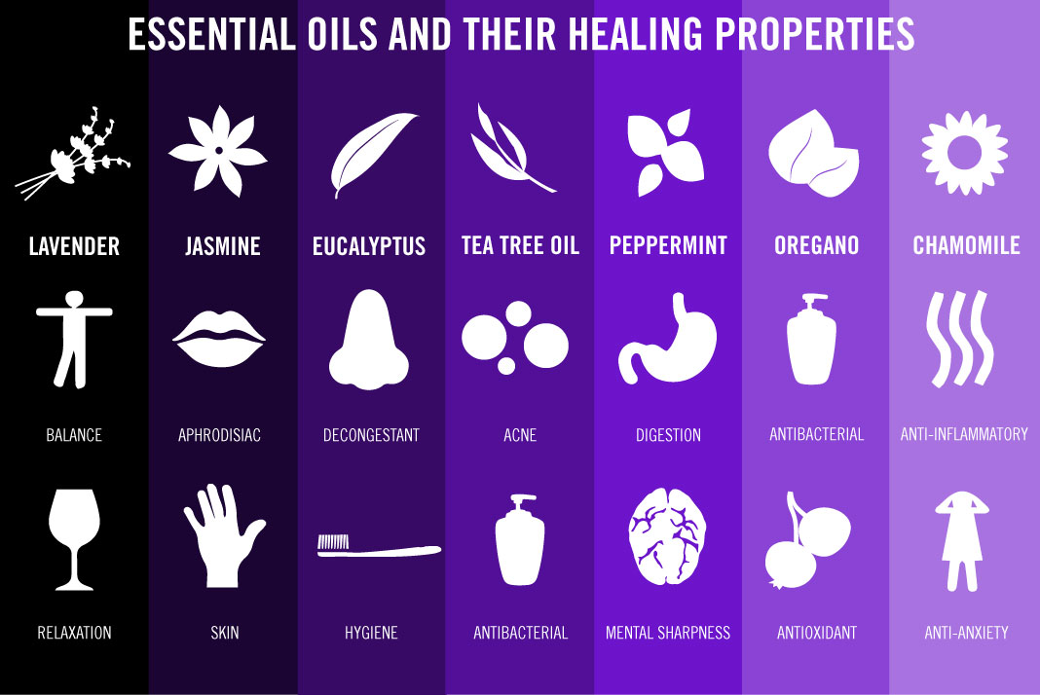
Chart source: Northwest Pharmacy.com
Works Cited
“AGILEASE IS HERE FOR ACUTE INFLAMMATION AND ACUTE JOINT DISCOMFORT!” EssentialOils4Sale, June 2016, yldist/essentialoils4sale/agilease-is-here-for-acute-inflammation-and-acute-joint-discomfort/. Accessed 23 Oct. 2016.
Deardeuff, LeAnne, and David Deardeuff. Inner Transformations Using Essential Oils:
Powerful Cleansing Protocols for Increased Energy and More Radiant Health. 2nd ed., Orem, Life Science Publishing, 2014.
Essential Oils Pocket Reference. 6th ed., Orem, Life Science Publishing, 2014.
“FDA Warning Letter to Young Living.” www.fda.gov/ICECI/EnforcementActions/WarningLetters/2014/ucm416023.htm. Accessed 4 Oct. 2016. Letter.
Heimer, Megan. “Essential Oils: Fad or Fantastic?” Living Whole, 10 Sept. 2014, living whole.org/essential-oil-fad-or-fantastic/. Accessed 21 Oct. 2016.
Kasper, Sigfried, et al. “Lavender oil preparation Silexan is effective in generalized anxiety disorder.” International Journal of Neuropsychophamacology, vol. 17, no. 6, 1 June 2014, pp. 859-69. Oxford Journals, doi.org/10.1017/S1461145714000017. Accessed 5 Oct. 2016.
Kligler, Benjamin, and Sapna Chaudhary. “Peppermint Oil.” American Family Physician, vol. 75, no. 7, 1 Apr. 2007, pp. 1027-30, aafp.org/afp/2007/0401/p1027.html#.V-u36IT-gDY.email. Accessed 4 Oct. 2016.
Mertas, Anna, et al. “The Influence of Tea Tree Oil (Melaleuca alternifolia) on Fluconazole Activity against Fluconazole-Resistant Candida Albicans Strains.” BioMed Research International, vol. 2015, 4 Feb. 2015, pp. 1-9. EBSCOhost. Accessed 25 Oct. 2016.
Stafford, Lindsay. “Using Essential Oils Against Drug Resistant Bacteria: New treatment possibilities for a global health priority?” HerbalGram, no. 88, Nov. 2010, pp. 32-45. EBSCOHOST. Accessed 4 Oct. 2016.
Stringer, Danielle McBurnett. “Why Essential Oils Aren’t Natural.” Kidnurse, 2 June 2015, www.kidnurse.org/why-essential-oils-aren’t-natural/. Accessed 5 Oct. 2016.
“2016 Product Guide.” Young Living, version 2, Feb. 2016, youngliving.com/en_US/products/product-guide/. Accessed 23 Oct. 2016.
“Understand the Facts Generalized Anxiety Disorder (GAD).” Anxiety and Depression Association of America, July 2016, adaa.org/understanding-anxiety/generalized- anxiety-disorder-gad. Accessed 21 Oct. 2016.

