101 Lab – Muscle Tissue Crossbridge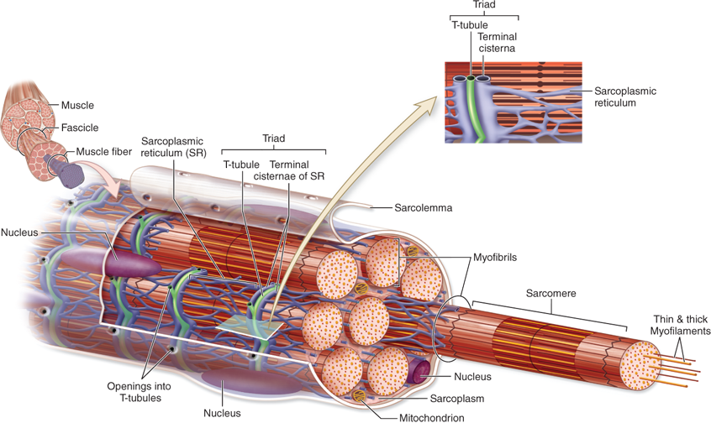
In a skeletal muscle cell, the cell membrane is known as the _______________________, cytoplasm is called ______________________, and the smooth endoplasmic reticulum is known as _____________________. A red protein containing heme and iron that stores oxygen in the cytoplasm of skeletal and cardiac muscle cells is ____________________, which is structurally similar to a subunit of hemoglobin. ____________________ are regularly spaced infoldings of the sarcolemma that contain extracellular fluid in their lumen. The function of T-tubules is to conduct __________________ potentials from the sarcolemma down into the cell and, specifically, to terminal cisternae of the sarcoplasmic reticulum (SR), which stores calcium ions (Ca²⁺). Voltage-gated channels between the terminal cisternae of the SR and T-tubules act as voltage sensors to cause release of Ca²⁺ into the sarcoplasm during an action potential.
A muscle fiber is a long, cylindrical skeletal muscle cell that contains many myofibrils, which are elongated contractile threads of myofilaments composed of thin and thick filaments. Thick filaments consist of myosin, while the thin filaments consist of actin, troponin, and tropomyosin. Myosin and actin are contractile proteins, but troponin and tropomyosin are regulatory proteins.
The sliding filament model of contraction: When signaled by a motor neuron, the thin filaments are pulled and slide over the thick filaments toward the M line causing greater overlap of actin and myosin. This overlap shortens the sarcomere by bringing the Z discs closer together. Neither the thin nor thick filaments change length during contraction.

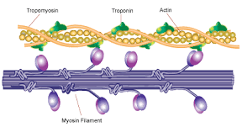
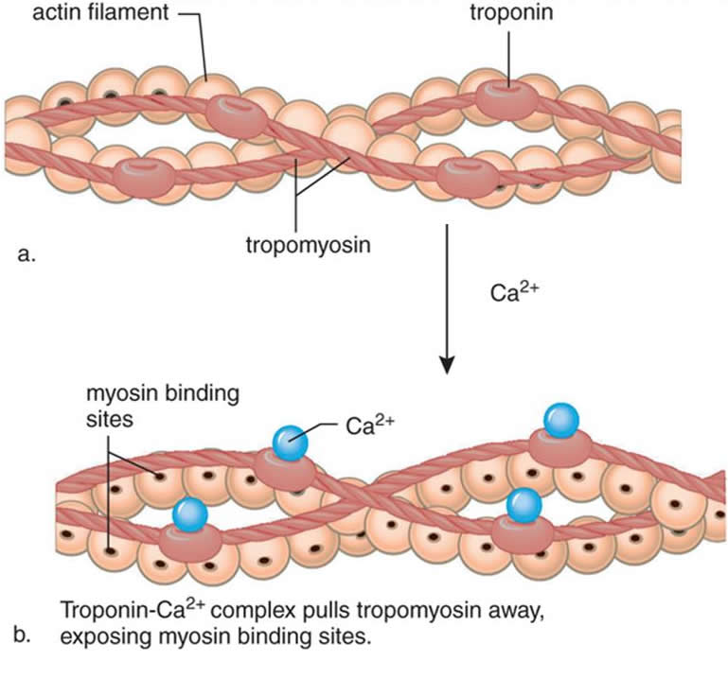
Two long strands of beadlike ____________________ molecules are twisted together with threadlike tropomyosin attached to troponin to form a thin filament. ____________________ has a long, fibrous tail and a globular head, which has binding sites for both actin and ATP. The chemical bond that is formed between myosin and actin is called a crossbridge. In a relaxed muscle, tropomyosin blocks actin from binding with myosin, thus preventing contraction. When the muscle cell is stimulated by an action potential, voltage-gated calcium channels open in the sarcoplasmic membrane and release calcium into the sarcoplasm. Some of this calcium attaches to troponin, which causes it to change shape, exposing binding sites for myosin (active sites) on the actin filaments. Myosin’s binding to actin causes _____________________ formation, and contraction of the muscle begins.
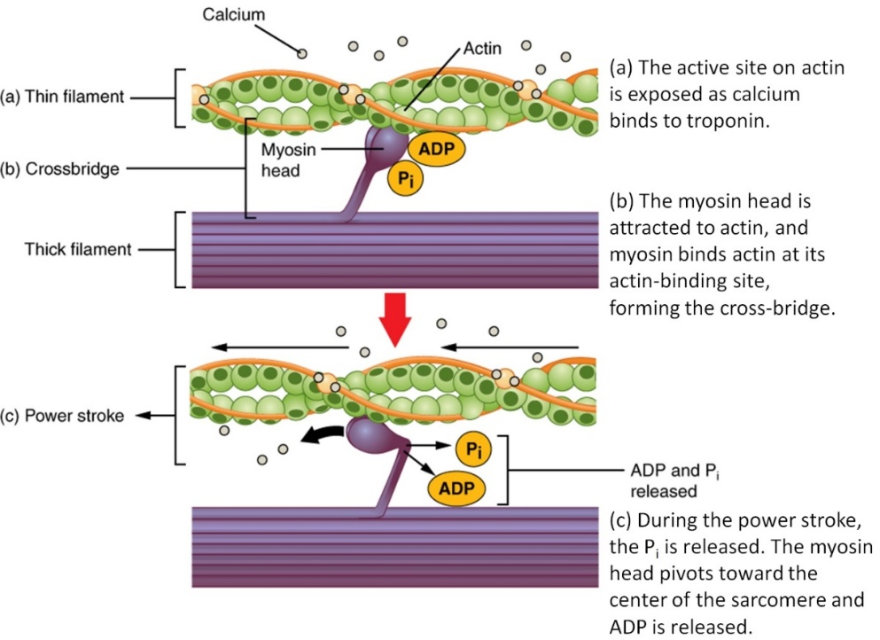
A ________________________________ is formed when myosin and actin bond. The __________________________ is when the myosin head pivots to pull the actin filament toward the M line. After the power stroke, __________________ binds with the cross bridge, which causes the crossbridge to detach from the _____________________, which is part of the thin filament. The myosin head is returned to its original position "cocked" by the energy released from the hydrolysis of ATP. As long as ________________ and _______________ are available, the cross-bridge cycle will continue. ATP is required by two different processes that are necessary to the contraction and relaxation of a muscle: the interaction between the thick and thin filaments of the sarcomeres (ATP detachment and resetting the myosin head), and the reuptake of calcium into SR by the Ca²⁺ pump.

In order for relaxation to occur, acetylcholine must be removed from the muscle cell's receptors. ATP must detach the crossbridge to allow the thin and thick filaments to slide back to their relaxed positions. Calcium is transported back into the SR by the Ca²⁺ pumps. Without cytoplasmic Ca²⁺, the blocking action of tropomyosin is restored and relaxation occurs.
